BRIEF DESCRIPTION OF CANDIDATE DATA SET
Here is an example of the dataset:
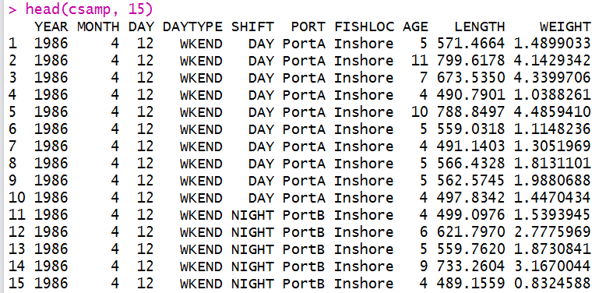
Here are summaries of each of the fields:
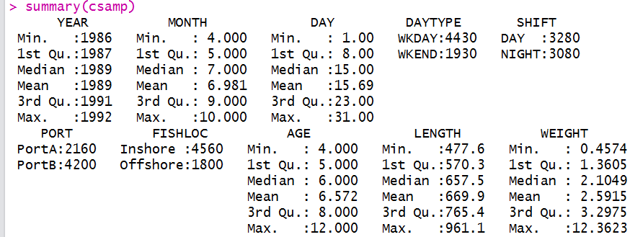

YEAR/MONTH/DAY: Only APR-OCT were included in the sampling
DAYTYPE: Whether this was a weekday or a weekend. In this example there were 2 sampling events per week and one per weekend, occurring on randomly selected days.
SHIFT: Each day that is selected for sampling is then randomly assigned a day or night shift
PORT: The port that the creel surveyor is sampling at on a particular day. The probability of sampling PortA is 0.33 and the probability of sampling PortB is 0.66. The port also determines the probability that each sample came from the inshore or offshore area. At PortA the probability of an inshore fish is 0.9 and at PortB the probability of an inshore fish is 0.6. Easy to include more ports.
FISHLOC: Origin of each sample. During each sampling event the clerk samples 10 fish and each fish is from the inshore or offshore population (these are meant to be spatially distinct so the origin is known with certainty). The inshore and offshore populations vary in (1) age composition (static over time – could make this change), (2) length/weight relationship parameter b, and (3) von Bertalanffy parameter Linf. Easy to incorporate variability in other parameters if necessary.
AGE/LENGTH/WEIGHT: Biological sampling data without observation error.

The figure below shows the linear process that determines the ports to sample, where the fish come from and what age each fish is. On each sampling date the clerk randomly chooses port A or port B with a fixed probability. The clerk then samples 10 fish, each of which can come from the inshore or the offshore population, with a fixed probability for each. The fish is then assigned an age using multinomial sampling based on fixed proportions determined by whether the fish came from the inshore or the offshore population.

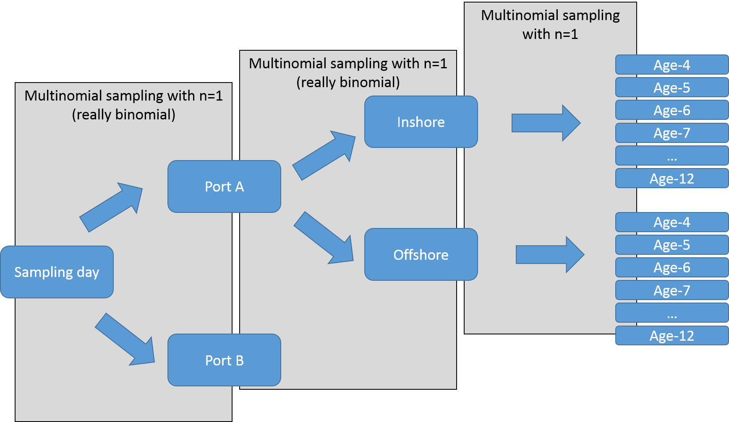

Age has been determined. Length is determined using the VB equation
$$L_{t}=L_{∞}\left(1-e^{-t-t_{0}}\right)$$
$L_{∞}$ is the only parameter that varies. It is distributed as normal with a mean that depends on whether it is an inshore or offshore fish but in each case has the same cv. The $L_{∞}$ for each fish is sampled from the appropriate distribution. There is also a temporal trend in $L_{∞}$. After $L_{∞}$ is sampled from one of the distributions the trend is applied:
$$L_{∞}^{'}=L_{∞}+m\left(Y_{n}-Y_{1}\right)$$
Where $L_{∞}^{'}$ is the adjusted value for $L_{∞}$, $m$ is a slope, $Y_{n}$ is the sampling year and $Y_{1}$ is the first year.
Weight is conditional on length according to
$$W=aL^{b}$$
$b$ is the only parameter that varies. The scenario is the same as for $L_{∞}$ where the inshore and offshore populations have a different mean $b$ but the cv is the same. Once a baseline value for $b$ is determined for each individual it is adjusted according to a seasonal trend. The trend is a sine wave where the minimum and maximum values of the curve are +/- a scaling factor (0.015) multiplied by the baseline $b$.
A plot of the seasonal trend:
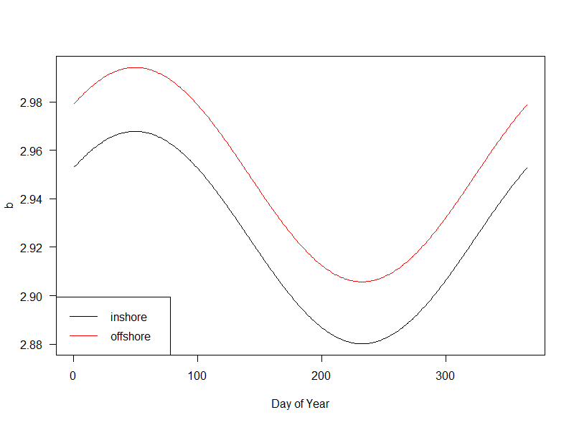
The timing of the maximum value for $b$ can be easily altered.

Below are some example plots that use the data set directly. I didn’t spend a ton of time adding legends and making these look nice, but I’m just hoping that they illustrate the types of things that we can do with the data. I tried to use a few different types of plots.
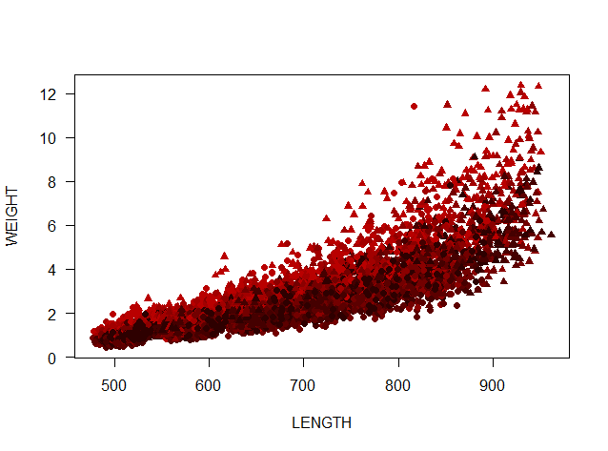
Length versus weight. Inshore records are circles and offshore records are triangles. The color represents the month of sampling, with redder values occurring earlier in the year and black values occurring later in the year. The previous plot shows that b is highest during the early part of the year and this is reflected by larger average weight-at-length.
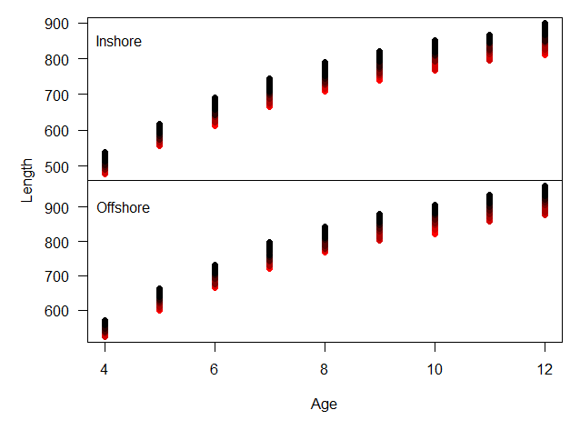
Length vs weight for inshore and offshore data. This time the colors are related to the year – red is earlier in the time series while black is later. The effect shows the impact of the increasing linear trend in Linf.

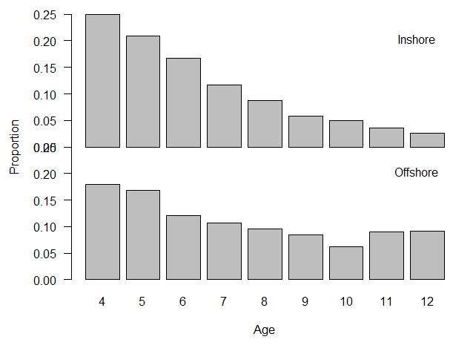
Age compositions for the inshore and offshore stocks.

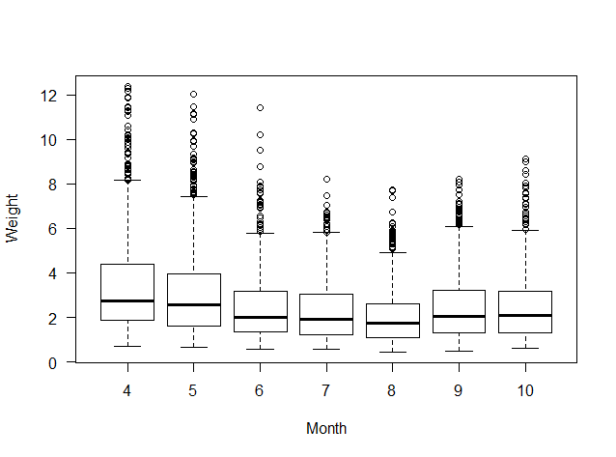
Variability in weight by month (not separated by stock).

One additional component that we could easily add to the data set is location (i.e., the fisherman reports an approximate location for catch). Students could make a plot of fishing locations where the size of each point was a function of fish length or something else.

